# Assignment 3 Report

1) (15 points)

Create a class blueprint that toggles a light when the player walks near it (or something similar)

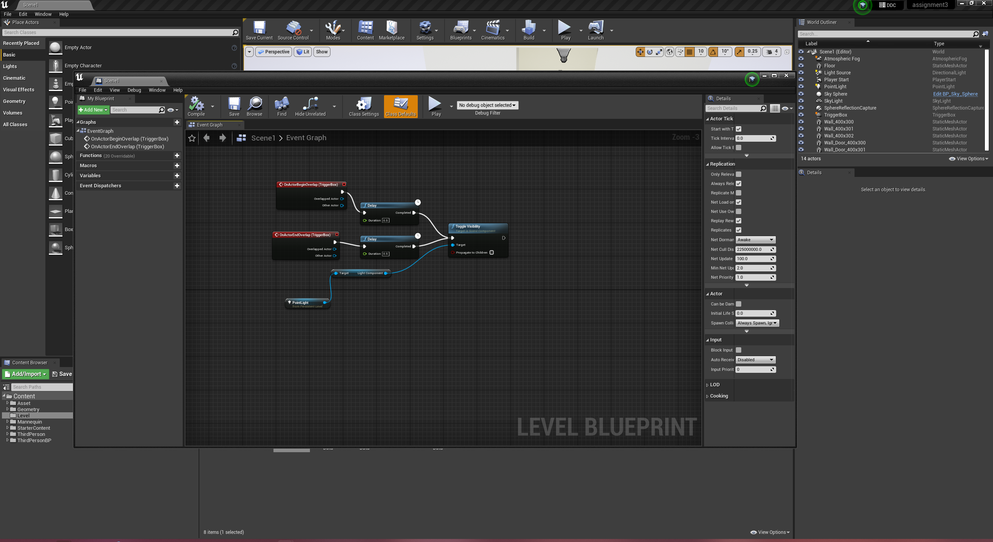

The level blueprint is located at folder Level Scene1.

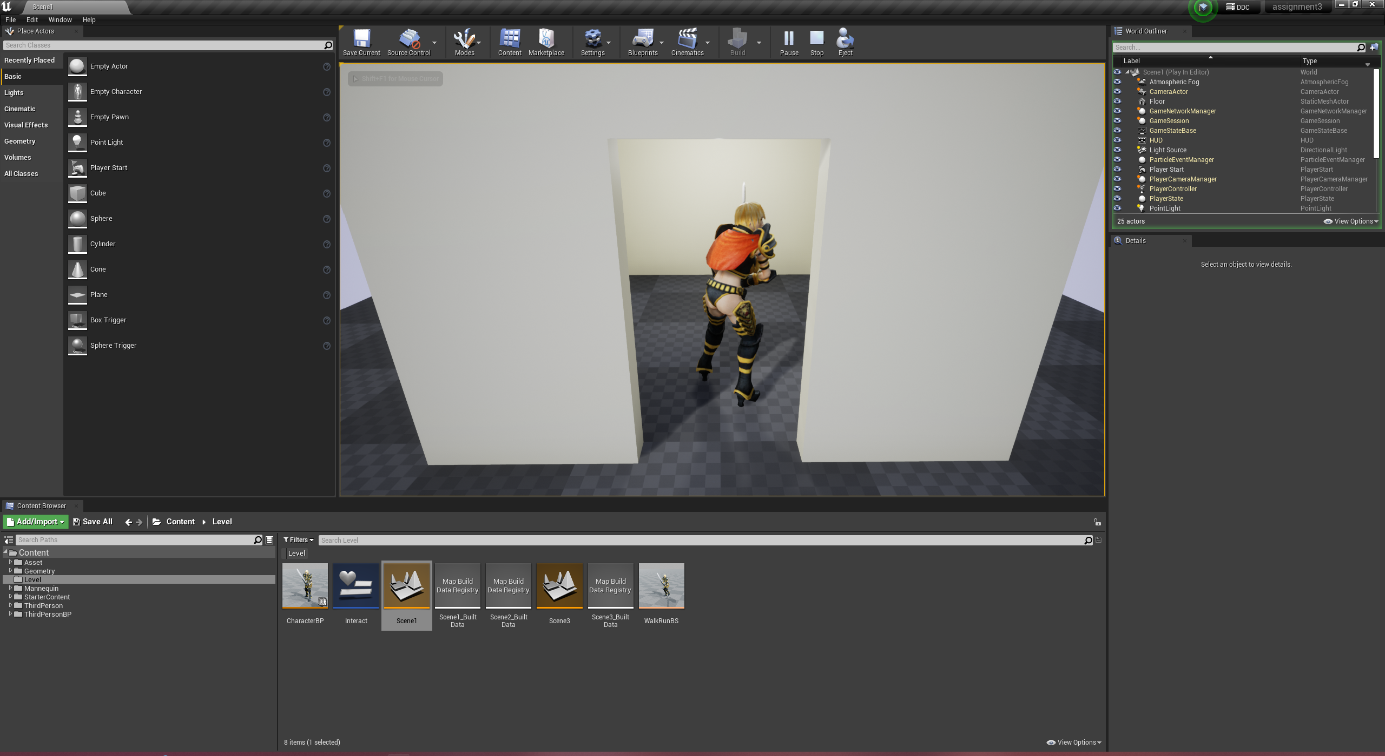

2) (15 points)

Create a blueprint that creates on on-screen prompt by pressing a key.

See  
Press E To Interact | On-Screen Prompt - Unreal Engine 4 Tutorial

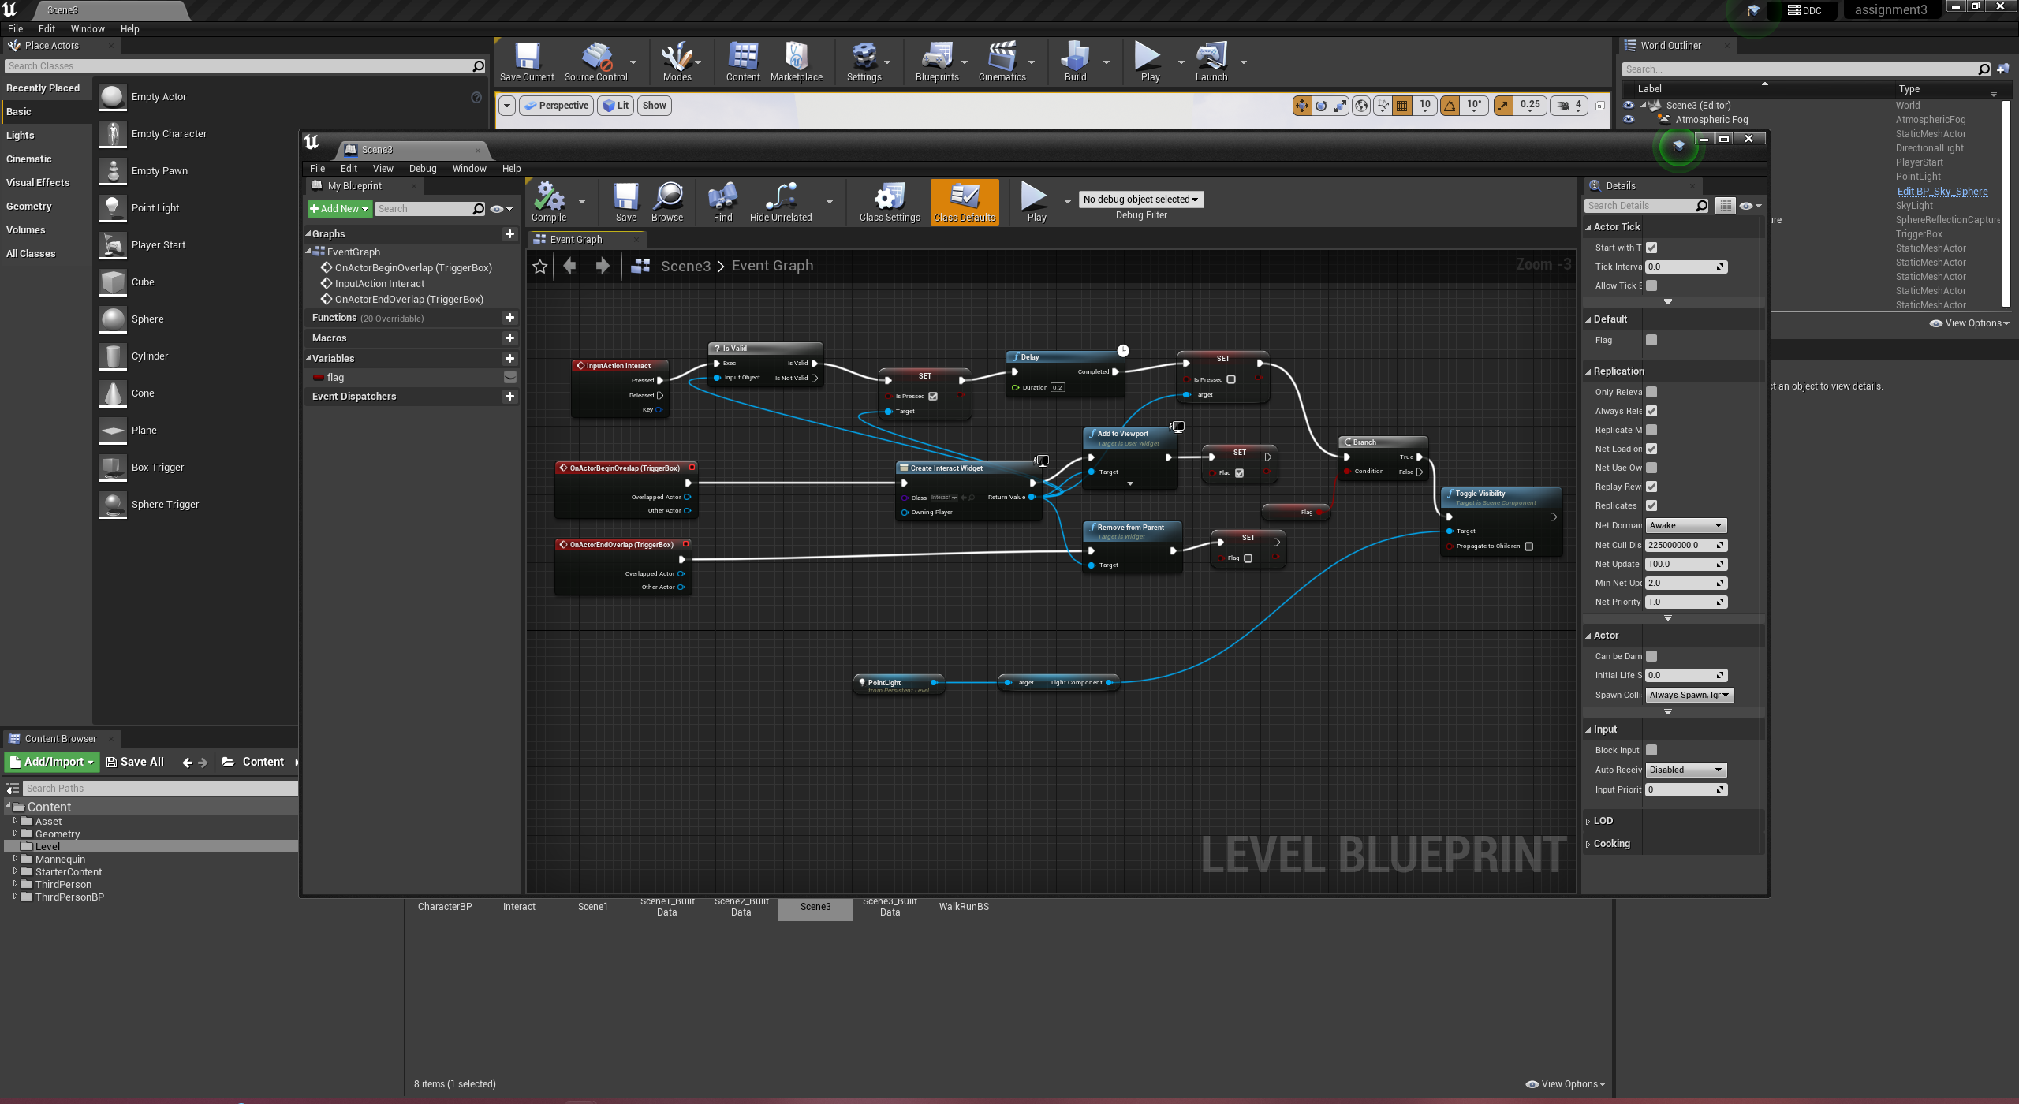

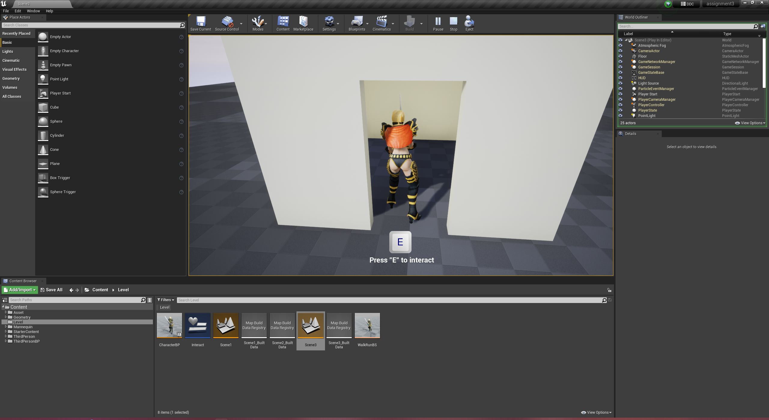

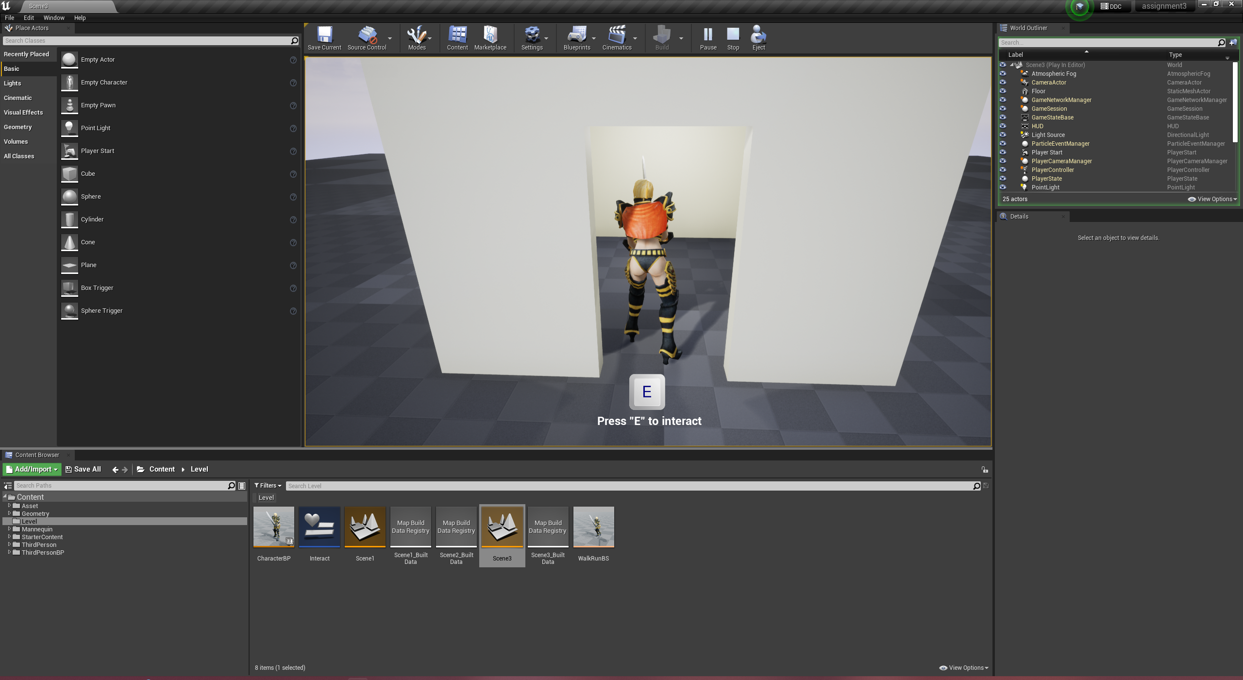

3) (40 points)

Create an animation blueprint that calls at least three different animations

See

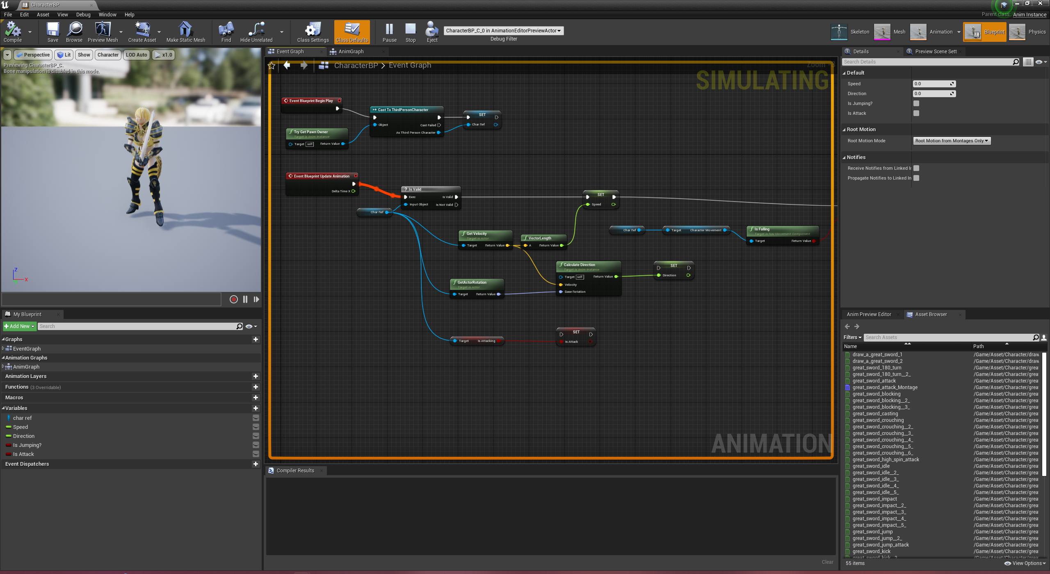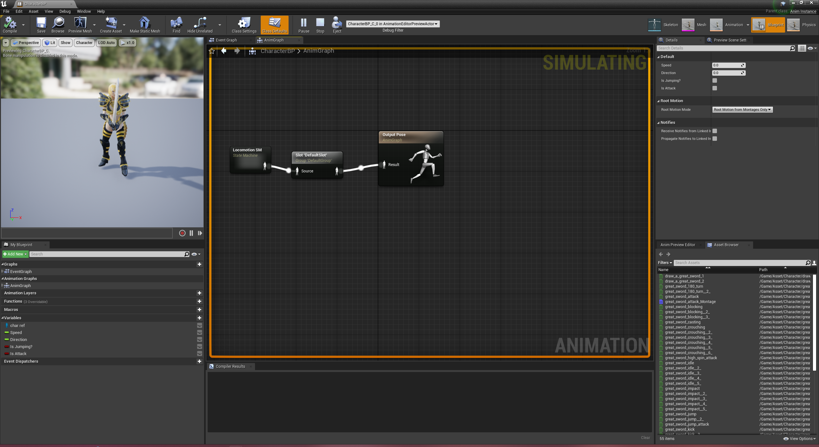

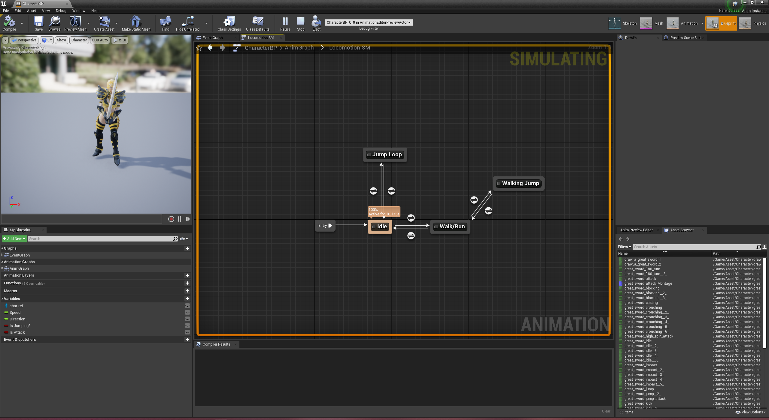

Implement six Animation

* Idle
* Walk/Run
* Jump
* Walking Jump
* Heavy Attack
* Light Attack

Using the animation montage to implement the attack.